Navigate Guide for Tutoring Appointments

This guide walks through 4 processes:
- How to schedule a tutoring appointment (page 2 – 7)
- How to access a tutoring appointment (page 8)
- How to cancel a tutoring appointment (page 9 – 10)
- How to reschedule a tutoring appointment (page 11 – 12)

If you have questions, please contact via email: tutoringservices@anokaramsey.edu or phone 763-433-1260

How to Schedule a Tutoring Appointment in Navigate
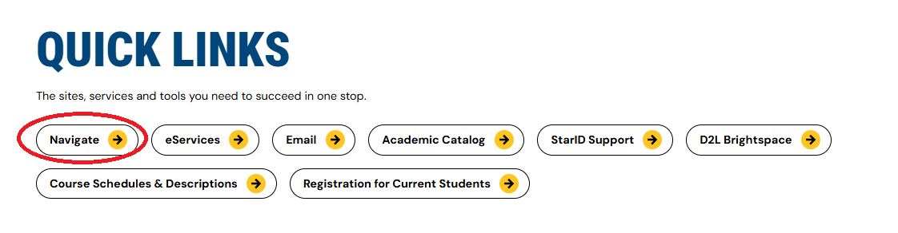
To access Navigate, go to the Anoka-Ramsey Website, from the top right corner go to INFORMATION FOR Current Students scroll down to QUICK LINKS click on Navigate.
Click on the blue box “Login with your school account”.
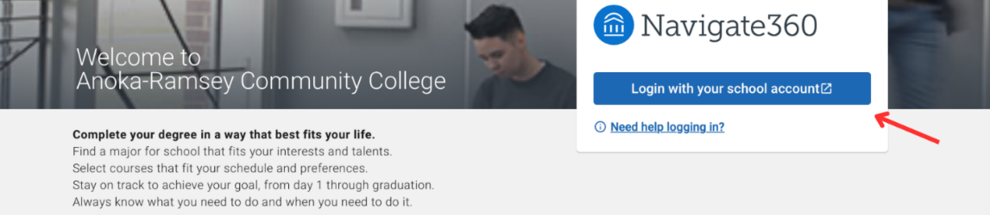
Login with your StarID and StarID Password.
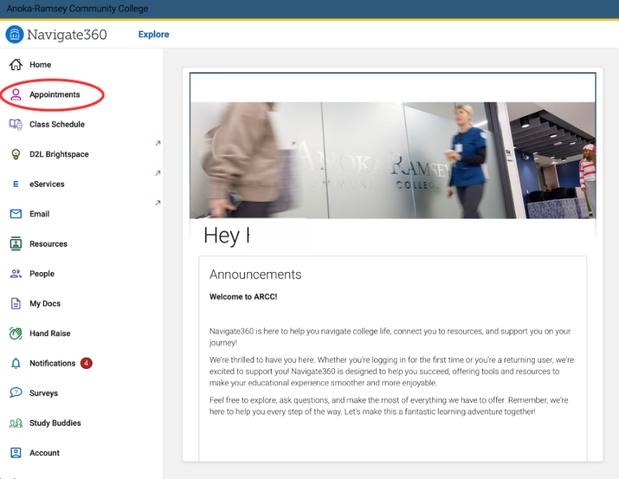
On the Homepage ridge-hand menu, click on the “Appointments”

Click on the blue box “Schedule an Appointment”
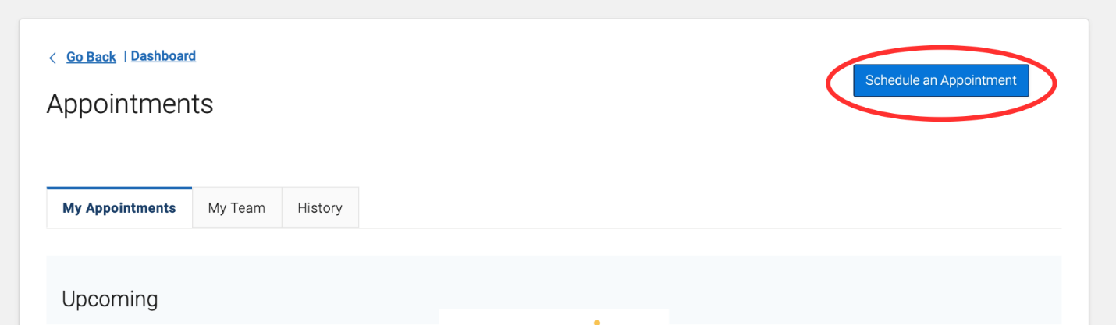
Step 1: Under what type of appointment would you like to schedule? choose Tutoring
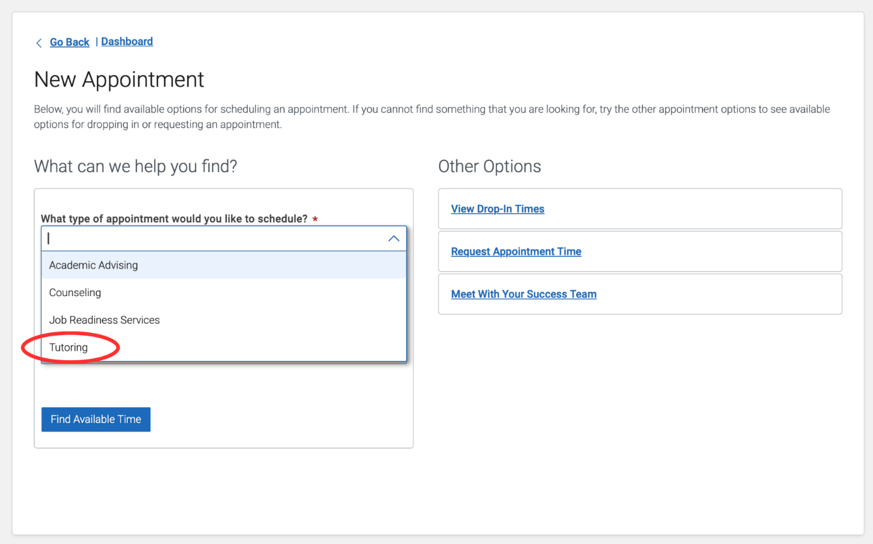
Step 2: Under Services, select the service that you are looking for:
- Accuplacer Preparation = help to prepare for the Accuplacer Math Test
- Class specific tutoring = help with current registered classes at the ARCC
- Dosage Caculation assistance = help with dosage calculation
- General Study Skills (not class specific) = help with study skills, time management, using resources, learning strategies, etc. We will not cover any content for any class specific under general study skills.
- Writing help (any class) – appointment = help writing paper with a writing tutor
- Writing help (any class) – written feedback = NOT a live appointment with a writing tutor, you should submit an essay, answer Pre-Appointment Questions hyperlink from your email, and then receive virtual feedback up to 2 business days. For more information, please visit this Virtual Written Feedback Instructions
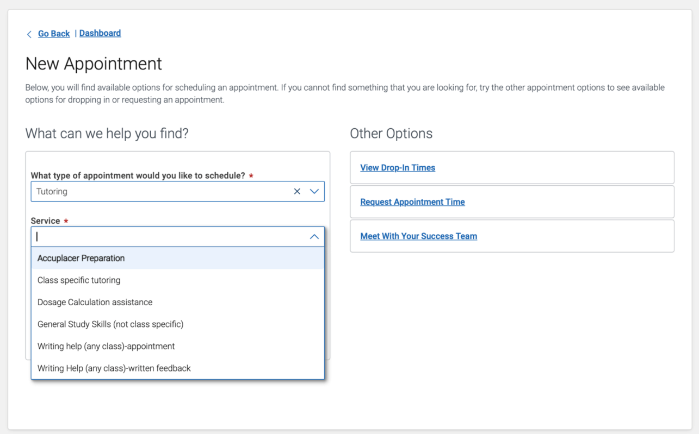

Step 3: Pick a Date. Note: you can only see tutors’ availability within 7 days in advance.
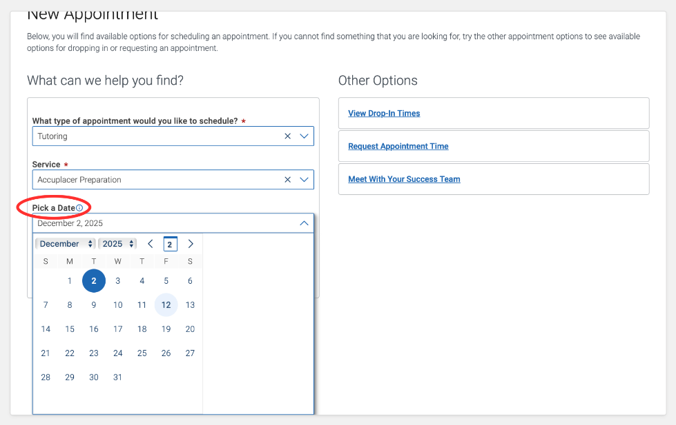

Step 4: click the blue box “Find Available Time”
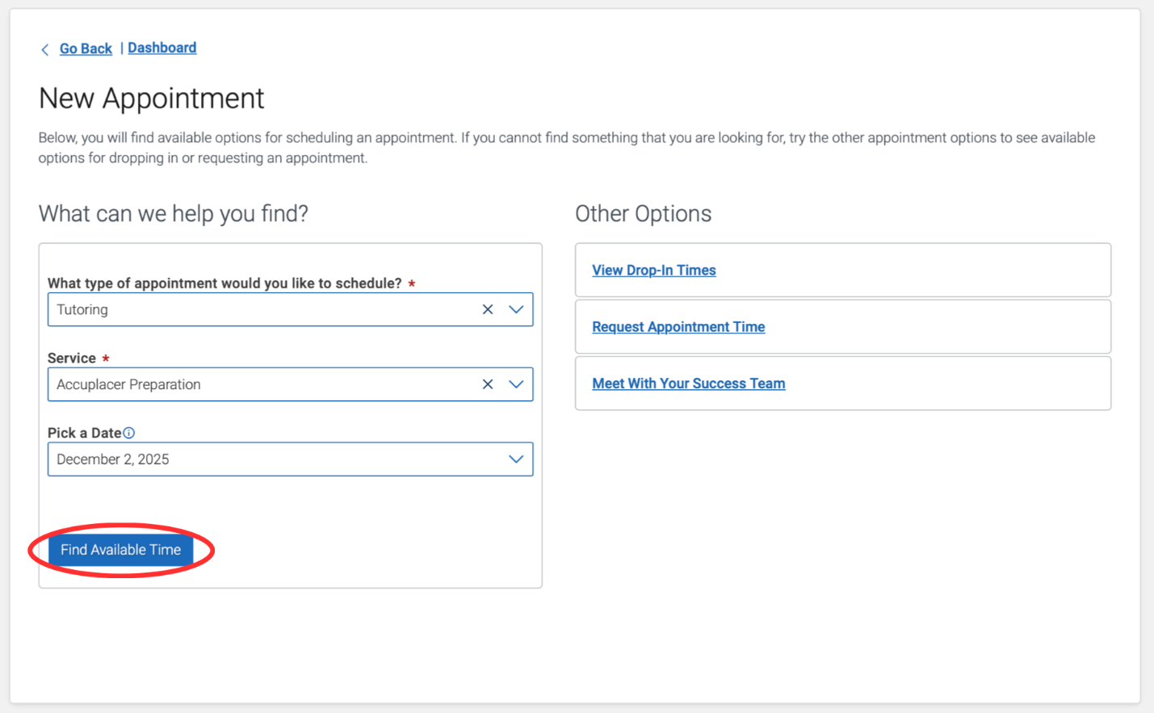
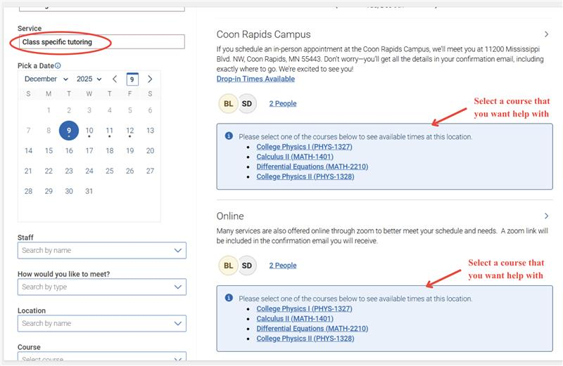
Step 5A: Under Service if you choose “Class specific tutoring”, you should select the course that you want to help with.
The Tutors’ availabilities appear select the location and time that work for you. If you don’t find any time that work for you, you can click “Request Alternate Appointment Time”
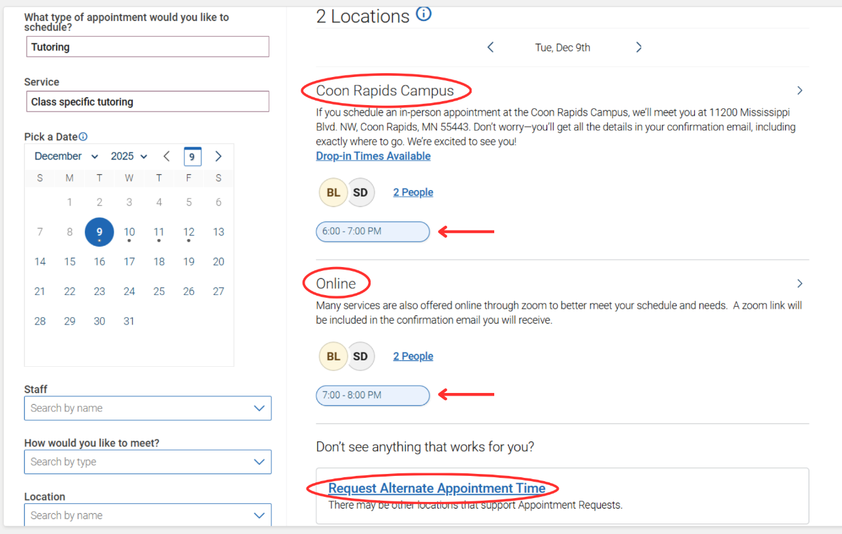

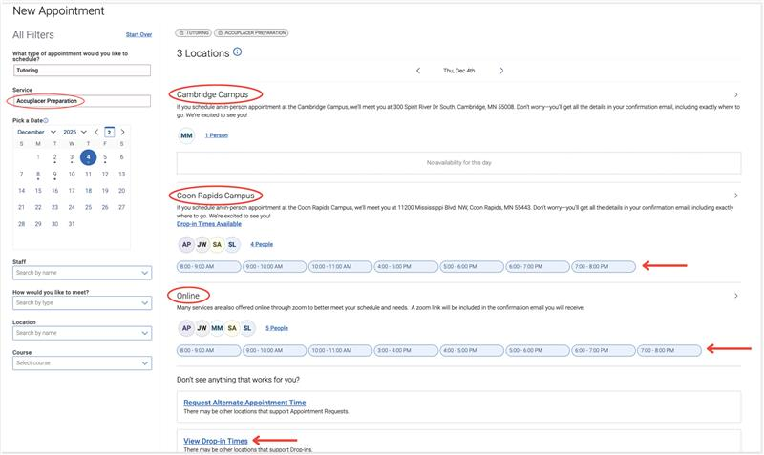
Step 5B: Under Service if you choose “Accuplacer Preparation” or “Dosage Caculation assistance” or “General Study Skills (not class specific)” or “Writing Help”, you do not choose a course. The Tutors’ availabilities appear select the location and time that work for you. If you don’t find any time that work for you, you can click “Request Alternate Appointment Time”
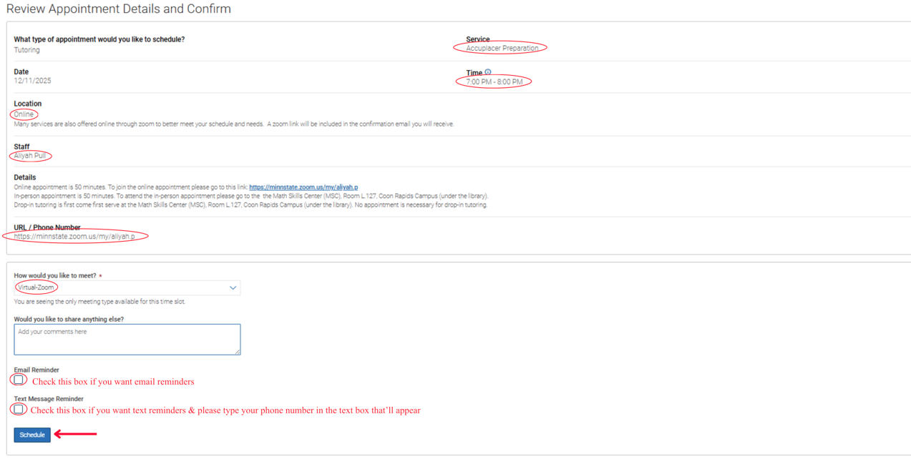
Step 6: After you chose the location and time that work for you, the Review Appointment Details and Confirm screen will appear check the appointment details information check the Email Reminder box if you want to receive email reminders or/and check the Text Message Reminder box if you want to receive text reminder (you should enter your phone number after you check the Text Message Reminder box) click the blue box “Schedule” if all the information is correct

Step 7: Once you click on the blue “Schedule”, the screen below will appear. You will receive an email to your ARCC email address confirming the appointment.


How to Access a Tutoring Appointment
The detailed appointment information can be found in your ARCC confirmation email.
Under Additional Details: it shows on campus location for an in-person appointment or drop-in tutoring or Zoom link for an online appointment
In-Person Appointments or Drop Ins:
Please visit our tutoring centers on the Rapids or Cambridge campuses. Please log in at the kiosk before your session and log out at the end of your session!
- Math Skills Center Rapids: Room L.127 (under the library) for MATH 0080, 0120, 0240, 0250, 1100, 1200, Medical Dosage calculation, and Accuplacer Prep,
- Academic Support Center Rapids: Room SC160 (across from the bookstore)
- The Writing Center is inside the ASC in Room SC163
- Academic Support Center Cambridge: Room D208

Online Appointments:
To join online appointments please go back to your ARCC confirmation email and click on the tutor’s Zoom link.

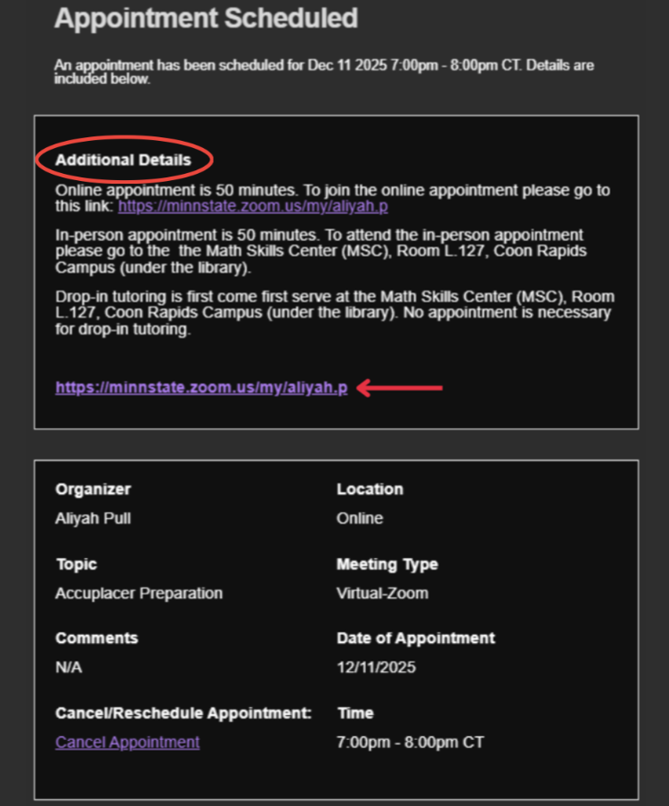
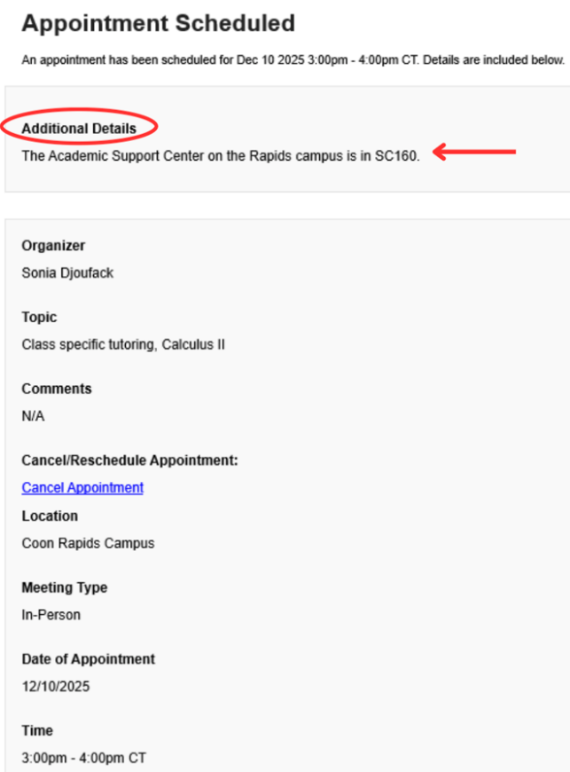

How to Cancel a Tutoring Appointment
Step 1: Go back to your ARCC confirmation email and click “Cancel Appointment”
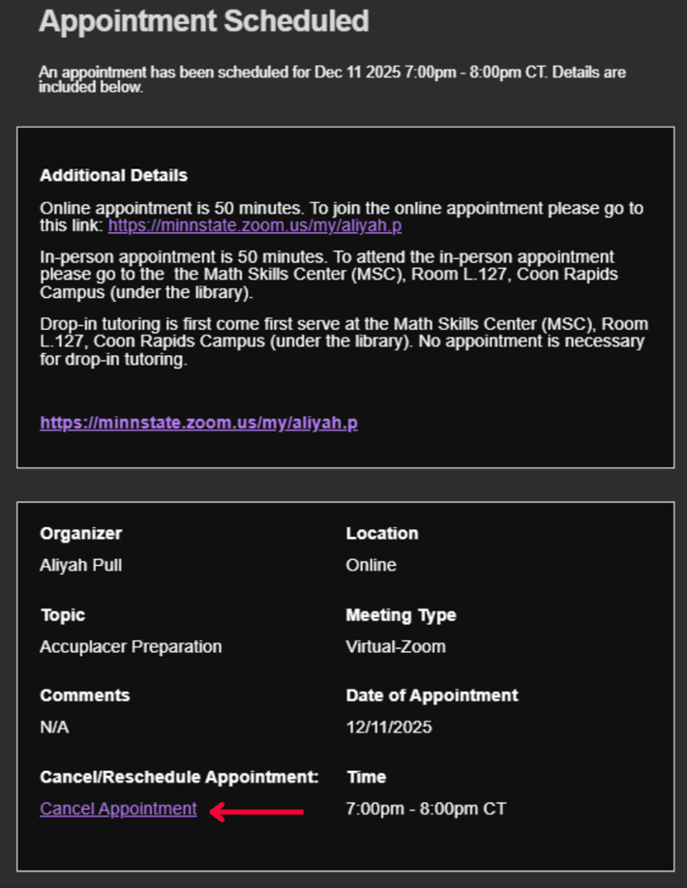

Step 2: It will take you back to Navigate 360 to the Cancel Appointment form fill out the form click the blue box “Cancel Appointment”
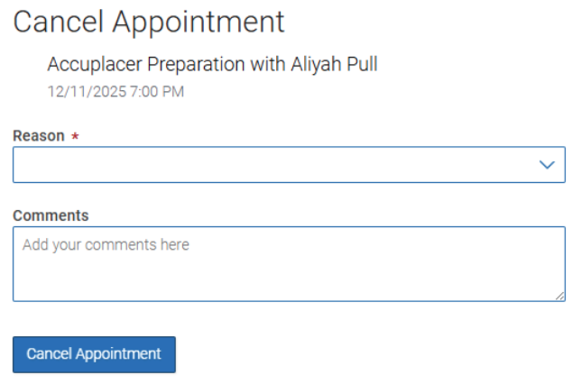

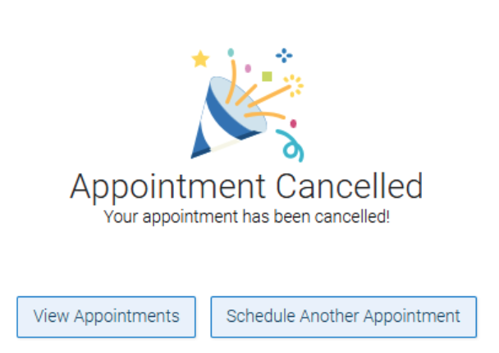
Step 3: the screen below will show up

Step 4: Receive the Appointment Meeting Cancelled email
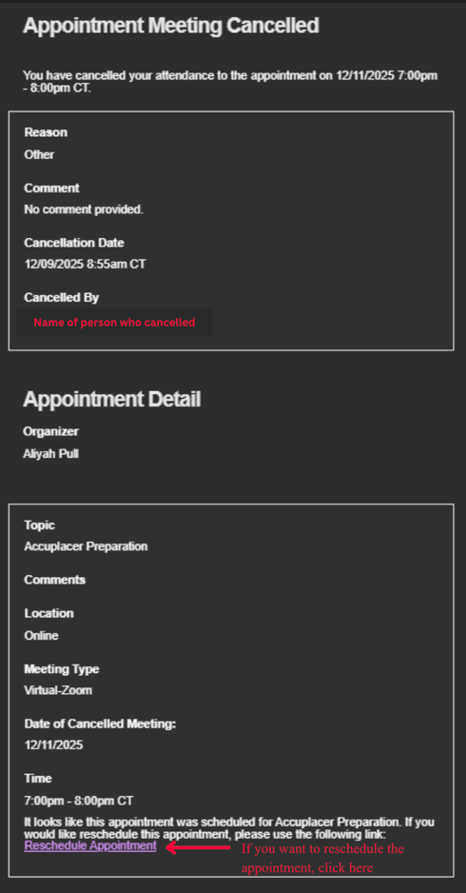

How to Reschedule Cancel a Tutoring Appointment
Way 1: access Navigate and follow the How to Schedule a Tutoring Appointment guide from page 2 – 8
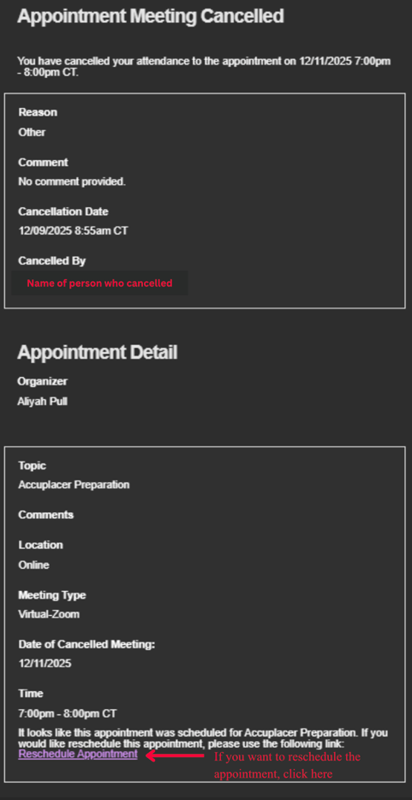
Way 2:
Step 1: from to your Appointment Meeting Cancelled email and click Reschedule Appointment

Step 2: it routes you to Navigate 360 follow the How to Schedule a Tutoring Appointment guide from page 2 – 8
