Function Inverses
For Questions 1 - 8, determine if the given functions are inverses of each other. Justify your answer using function composition.
- $g(x)=4-\frac{3}{2}x$ and $f(x)=\frac{1}{2}x+\frac{3}{2}$
- $g(n)=-\frac{12+2n}{3}$ and $f(x)=\frac{6n-5}{5}$
- $f(n)=\frac{n-16}{4}$ and $g(n)=4n+16$
- $f(x)=-\frac{4}{7}x-\frac{16}{7}$ and $g(x)=\frac{3}{2}x-\frac{3}{2}$
- $f(n)=-(n+1)^{3}$ and $g(n)=3+n^{3}$
- $f(n)=2(n-2)^{3}$ and $g(n)=\frac{\sqrt[3]{4n}+4}{2}$
- $f(x)=-\frac{4}{x+2}+2$ and $h(x)=-\frac{1}{x+3}$
- $g(x)=-\frac{2}{x}-1$ and $f(x)=-\frac{2}{x+1}$
For Questions 9 - 16, find the inverse of each function.
- $h(x)=\sqrt[3]{x}-3$
- $g(x)=\frac{1}{x}-2$
- $h(x)=2x^{3}+3$
- $g(x)=-4x+1$
- $g(x)=\frac{7x+18}{2}$
- $f(x)=x+3$
- $f(x)=-x+3$
- $f(x)=4x$
For Questions 17 - 20, find the inverse of each function. Then graph the function and its inverse on the same coordinate plane.
- $f(x)=-1-\frac{1}{5}x$
- 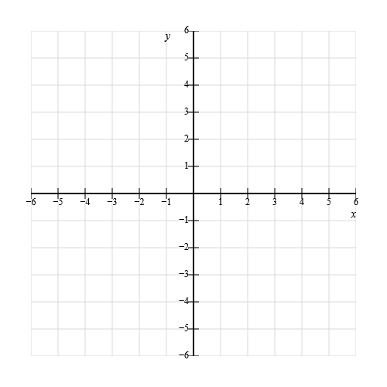
- $g(x)=\frac{1}{x-1}$
- $f(x)=-2x^{3}+1$
- $g(x)=-\frac{x+5}{3}$

Answer Key
- $g(x)=4-\frac{3}{2}x$ and $f(x)=\frac{1}{2}x+\frac{3}{2}$ Answer: No.
- $g(n)=-\frac{12+2n}{3}$ and $f(x)=\frac{6n-5}{5}$ Answer: No.
- $f(n)=\frac{n-16}{4}$ and $g(n)=4n+16$ Answer: Yes.
- $f(x)=-\frac{4}{7}x-\frac{16}{7}$ and $g(x)=\frac{3}{2}x-\frac{3}{2}$ Answer: No.
- $f(n)=-(n+1)^{3}$ and $g(n)=3+n^{3}$ Answer: No.
- $f(n)=2(n-2)^{3}$ and $g(n)=\frac{\sqrt[3]{4n}+4}{2}$ Answer: Yes.
- $f(x)=-\frac{4}{x+2}+2$ and $h(x)=-\frac{1}{x+3}$ Answer: No.
- $g(x)=-\frac{2}{x}-1$ and $f(x)=-\frac{2}{x+1}$ Answer: Yes.
- $h(x)=\sqrt[3]{x}-3$ Answer: h inverse of x $h^{-1}(x)$$={(x+3)}^{3}$
- $g(x)=\frac{1}{x}-2$ Answer: g inverse of x $g^{-1}(x)$$=\frac{1}{x+2}$
- $h(x)=2x^{3}+3$ Answer: h inverse of x $h^{-1}(x)$$=\sqrt[3]{\frac{x-3}{2}}$
- $g(x)=-4x+1$ Answer: g inverse of x $g^{-1}(x)$$=-\frac{1}{4}x+\frac{1}{4}$
- $g(x)=\frac{7x+18}{2}$ Answer: g inverse of x $g^{-1}(x)$$=\frac{2x-18}{7}$
- $f(x)=x+3$ Answer: f inverse of x $f^{-1}(x)$$=x-3$
- $f(x)=-x+3$ Answer: f inverse of x $f^{-1}(x)$$=-x+3$
- $f(x)=4x$ Answer: f inverse of x $f^{-1}(x)$$=\frac{x}{4}$
- $f(x)=-1-\frac{1}{5}x$ Answer: f inverse of x $f^{-1}(x)$$=-5x-5$
See the below grid for the graph of $f$(the thinner, solid line in red) and the graph of F inverse $f^{-1}$ (the thicker, dashed line in blue).
- 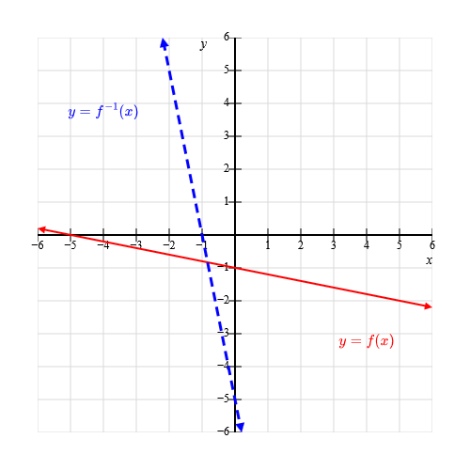
- $g(x)=\frac{1}{x-1}$ Answer: g inverse of x $g^{-1}(x)$$=\frac{1}{x}+1$
See the below grid for the graph of $g$(the thinner, solid curve in red) and the graph of g inverse $g^{-1}$ (the thicker, dashed curve in blue).
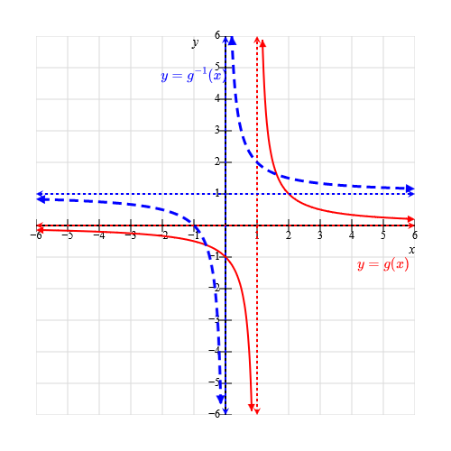
- $f(x)=-2x^{3}+1$ Answer: f inverse of x $f^{-1}(x)$$=\sqrt[3]{\frac{1-x}{2}}$
See the below grid for the graph of $f$(the thinner, solid curve in red) and the graph of F inverse $f^{-1}$ (the thicker, dashed curve in blue).
- 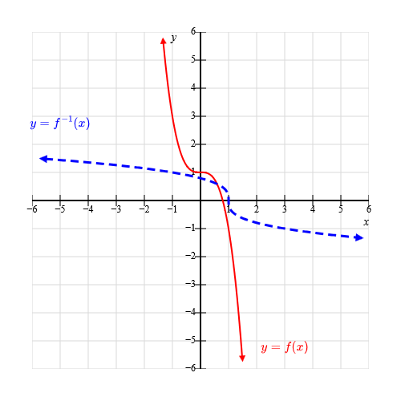
- $g(x)=-\frac{x+5}{3}$ Answer: g inverse of x $g^{-1}(x)$$=-3x-5$
See the below grid for the graph of $g$(the thinner, solid line in red) and the graph of g inverse $g^{-1}$ (the thicker, dashed line in blue).
- 