Solving Systems of Linear Inequalities
Sketch the solution set to each system of linear inequalities.
- $\left\{\begin{matrix} y≤-x-2 \\ y≥-5x+2\end{matrix}\right.$
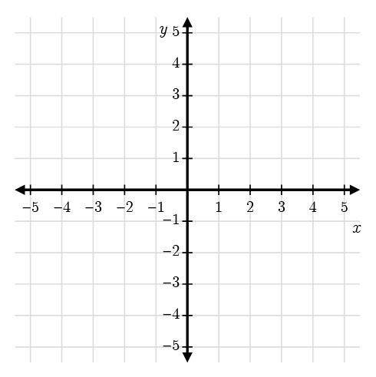
- $\left\{\begin{matrix} y>-x-2 \\ y<-5x+2\end{matrix}\right.$
- $\left\{\begin{matrix} y≤\frac{1}{2}x+2 \\ y<-2x-3\end{matrix}\right.$
- $\left\{\begin{matrix} x≤-3 \\ y<\frac{5}{3}x+2\end{matrix}\right.$
- $\left\{\begin{matrix} y≤-\frac{5}{2}x-2 \\ y<-\frac{1}{2}x+2\end{matrix}\right.$
- $\left\{\begin{matrix} y≥\frac{2}{3}x+3 \\ y>-\frac{4}{3}x-3\end{matrix}\right.$
- $\left\{\begin{matrix} 4x+y<2 \\ y>-2\end{matrix}\right.$
- 3x+2y≥-2 3x+2y≤2

Answer Key
- $\left\{\begin{matrix} y≤-x-2 \\ y≥-5x+2\end{matrix}\right.$
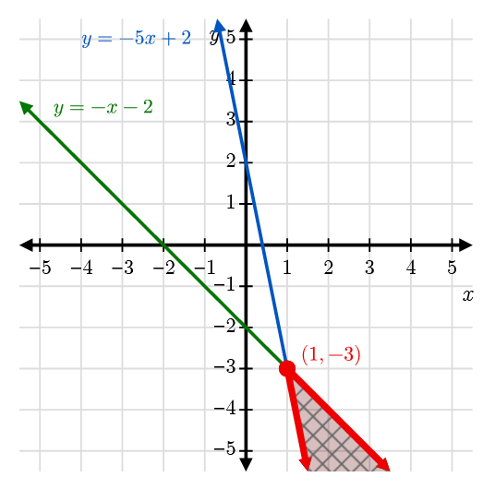
- $\left\{\begin{matrix} y>-x-2 \\ y<-5x+2\end{matrix}\right.$
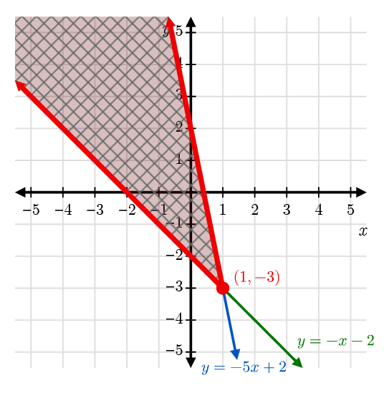
- $\left\{\begin{matrix} y≤\frac{1}{2}x+2 \\ y<-2x-3\end{matrix}\right.$
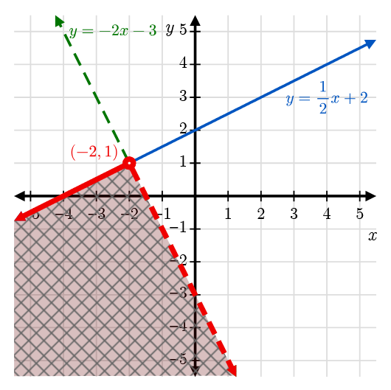
- $\left\{\begin{matrix} x≤-3 \\ y<\frac{5}{3}x+2\end{matrix}\right.$
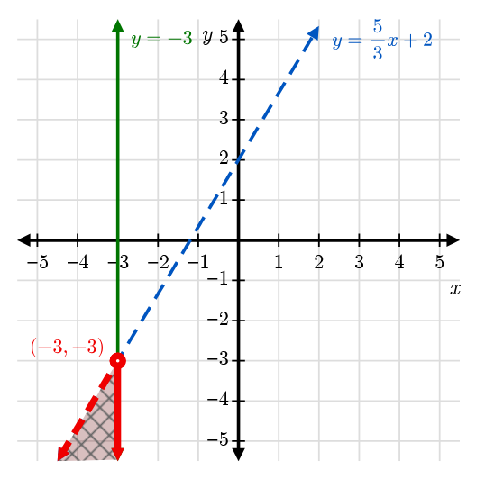
- $\left\{\begin{matrix} y≤-\frac{5}{2}x-2 \\ y<-\frac{1}{2}x+2\end{matrix}\right.$
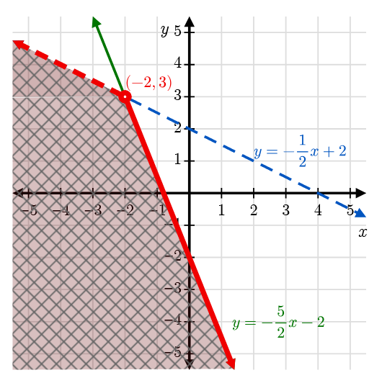
- $\left\{\begin{matrix} y≥\frac{2}{3}x+3 \\ y>-\frac{4}{3}x-3\end{matrix}\right.$
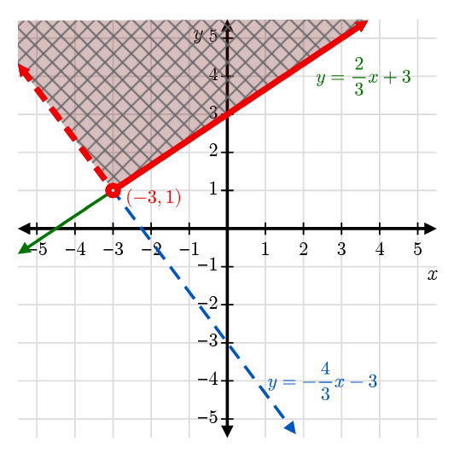
- $\left\{\begin{matrix} 4x+y<2 \\ y>-2\end{matrix}\right.$
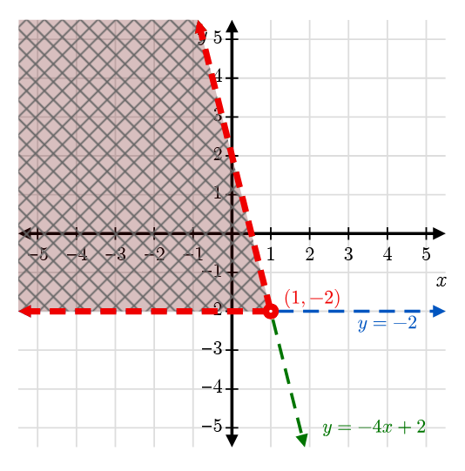
- 3x+2y≥-2 3x+2y≤2
