ARCC Tutoring Services | 763-433-1260
Rapids: Math Skills Center, Room L-127
Cambridge: ASC, Room D-208

Graphing Polynomials

Standard form:
$$a_{n}x^{n}+a_{n-1}x^{n-1}+⋯+a_{2}x^{2}+a_{1}x+a_{0}$$
Domain: All real numbers
At most $n$real zeros.
At most $n-1$ turning points.

Real zeros/x-intercepts:
Multiplicity $m$ of real zero $r$ | Behavior of graph near $x$-intercept $r$
Even  Multiplicity | Touches  similar to a parabola  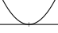
Odd  Multiplicity | Crosses  like a line if $m=1$  but more like a cubic if $m>1$  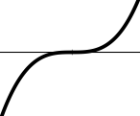
End behavior: For large $\left|x\right|$, the graph will resemble that of $y=a_{n}x^{n}$:
Degree $n$ | Leading coefficient $a_{n}$
 | Positive | Negative
Even  Degree | 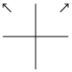 | 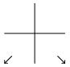
Odd  Degree | 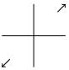 | 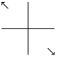

Polynomial Examples
$$f\left(x\right)=-5x^{3}+10x^{2}+20x-40$$
Factor: $f\left(x\right)=-5{\left(x-2\right)}^{2}\left(x+2\right)$
Zeros: $x=2$ (mult. $2$; touches)
$x=-2$ (mult. $1$; crosses)
$y$-intercept: $f\left(0\right)=-40⇒\left(0,-40\right)$
End behavior: For large $|x|$, the function behaves like $y=-5x^{3}$.
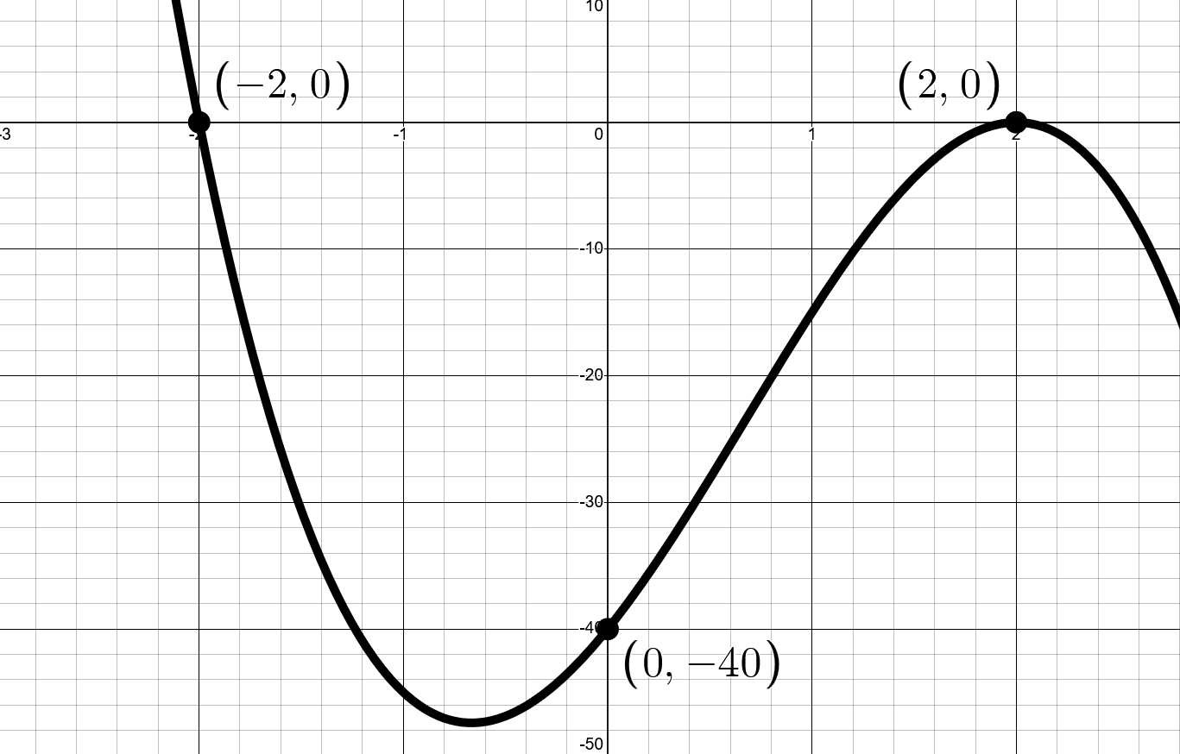
$$g\left(x\right)=2{\left(x-1\right)}^{3}\left(x+4\right){\left(x^{2}-10\right)}^{4}$$
Zeros: $x=1$ (mult. $3$; crosses)
$x=-4$ (mult. $1$; crosses)
$x=±\sqrt{10}$ (each mult. $4$; touches)
$y$-intercept:
$$g\left(0\right)=-80000⇒\left(0,-80000\right)$$
End behavior: For large $\left|x\right|$, the function will behave like
$y=2{\left(x\right)}^{3}\left(x\right){\left(x^{2}\right)}^{4}=2x^{12}$
